**ELECTRICITY BILL MANAGEMENT SYSTEM**

**Domain Description:**

The Electricity Bill Management System is designed to manage and automate the billing process for electricity consumption. This system is relevant in the context of utility services where customers are billed based on their electricity consumption. It helps utility companies efficiently track and manage customer information, meter readings, rates, and billing transactions.

**Entity-Relationship Diagram (ERD):**

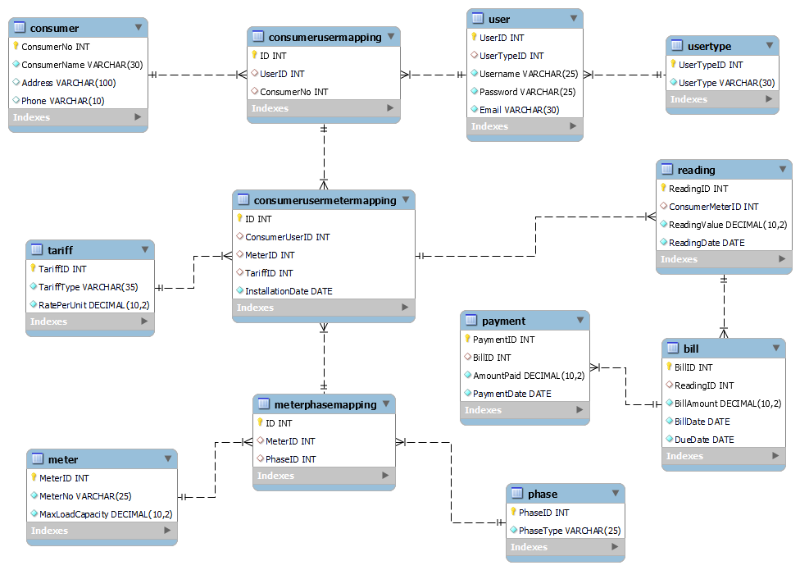

**Table Details:**

**User Type Table**

|  |  |  |
| --- | --- | --- |
| **Field** | **Data Type** | **Constraints** |
| UserTypeID | INT | Primary Key |
| UserType | VARCHAR | Not Null |

**Consumer Table**

|  |  |  |
| --- | --- | --- |
| **Field** | **Data Type** | **Constraints** |
| ConsumerNo | INT | Primary Key |
| ConsumerName | VARCHAR | Not Null |
| Address | VARCHAR | Not Null |
| Phone | VARCHAR | Not Null |

**Meter Table**

|  |  |  |
| --- | --- | --- |
| **Field** | **Data Type** | **Constraints** |
| MeterID | INT | Primary Key |
| MeterNo | VARCHAR | Not Null |
| MaxLoadCapacity | DECIMAL | Not Null |

**Phase Table**

|  |  |  |
| --- | --- | --- |
| **Field** | **Data Type** | **Constraints** |
| PhaseID | INT | Primary Key |
| PhaseType | VARCHAR | Not Null |

**Tariff Table**

|  |  |  |
| --- | --- | --- |
| **Field** | **Data Type** | **Constraints** |
| TariffID | INT | Primary Key |
| Tarifftype | VARCHAR | Not Null |
| RatePerUnit | DECIMAL | Not Null |

**User Table**

|  |  |  |
| --- | --- | --- |
| **Field** | **Data Type** | **Constraints** |
| UserID | INT | Primary Key |
| UserTypeID | INT | Foreign Key (UserType) |
| UserName | VARCHAR | Not Null |
| Password | VARCHAR | Not Null |
| Email | VARCHAR | Not Null |

**Meter Phase Mapping Table**

|  |  |  |
| --- | --- | --- |
| **Field** | **Data Type** | **Constraints** |
| ID | INT | Primary Key |
| MeterID | INT | Foreign Key (Meter) |
| PhaseID | INT | Foreign Key (Phase) |

**Consumer User Mapping Table**

|  |  |  |
| --- | --- | --- |
| **Field** | **Data Type** | **Constraints** |
| ID | INT | Primary Key |
| UserID | INT | Foreign Key (User) |
| ConsumerNo | INT | Foreign Key (Consumer) |

**Consumer User Meter Mapping Table**

|  |  |  |
| --- | --- | --- |
| **Field** | **Data Type** | **Constraints** |
| ID | INT | Primary Key |
| ConsumerUserID | INT | Foreign Key (ConsumerUser) |
| MeterID | INT | Foreign Key (MeterPhase) |
| TariffID | INT | Foreign Key (Tariff) |
| InstallationDate | DATE | Not Null |

**Reading Table**

|  |  |  |
| --- | --- | --- |
| **Field** | **Data Type** | **Constraints** |
| ReadingID | INT | Primary Key |
| ConsumerMeterID | INT | Foreign Key (ConsumerUserMeter) |
| ReadingValue | DECIMAL | Not Null |
| ReadingDate | DATE | Not Null |

**Bill Table**

|  |  |  |
| --- | --- | --- |
| **Field** | **Data Type** | **Constraints** |
| BillID | INT | Primary Key |
| ReadingID | INT | Foreign Key (Reading) |
| BillAmount | DECIMAL | Not Null |
| BillDate | DATE | Not Null |
| DueDate | DATE | Not Null |

**Payment Table**

|  |  |  |
| --- | --- | --- |
| **Field** | **Data Type** | **Constraints** |
| PaymentID | INT | Primary Key |
| BillID | INT | Foreign Key (Bill) |
| AmountPaid | DECIMAL | Not Null |
| PaymentDate | DATE | Not Null |